**Objective\Theme:**

Top Speed Triumph is a multiplayer car racing game developed using c# language. The main objective of this game is that, the player which is able to survive the incomming traffic till last is the winner. The score is incremented at every tick of the timer used and the one to survive till last, ends up having the most score.

The theme of this game is that the two cars in different lanes are accelerating in wrong direction. The difficulty of the game inceases every second with the increase in the speed of incomming traffic. Player 1 controls the car using W,A,S,D keys while player 2 uses arrow keys. There are different sound effects involved in this game making it more interesting. Before the start of the timer (Game), there is a sound of car starting and getting ready for the race which is followed by car accelerating sound which starts with the start of the race. At last there is also a CRASH sound when a race car collides with an incomming traffic car.

Cars of different model and colors are involved making the game look more colorfull. Even the road lanes include many details including lanes and road seperations etc.

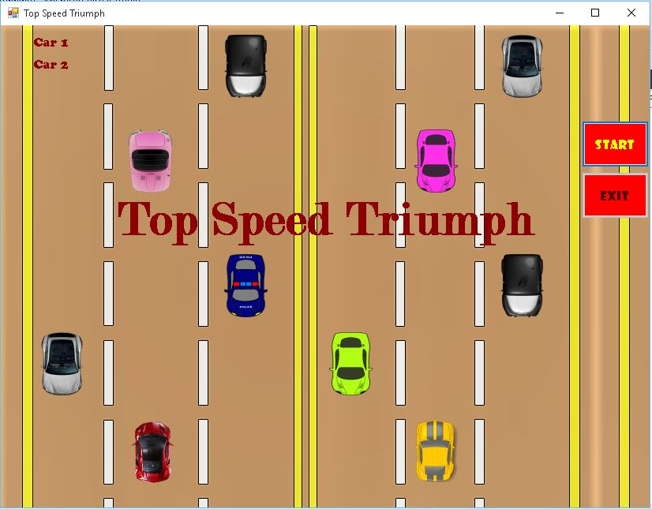.

**CODE:**

using System;

using System.Collections.Generic;

using System.ComponentModel;

using System.Data;

using System.Drawing;

using System.Linq;

using System.Text;

using System.Threading.Tasks;

using System.Windows.Forms;

using System.Media;

namespace Project

{

public partial class crash2 : Form

{

public crash2()

{

InitializeComponent();

//Labels used:

crash.Visible = false;

crash1.Visible = false;

over.Visible = false;

winner.Visible = false;

}

int carspeed = 15; //change in cars

double trafficspeed1, trafficspeed2; // speed of the game(difficulty)

int score1, score2 = 0;

// Sounds used:

SoundPlayer crash_sound = new SoundPlayer(@"E:/crash.wav");

SoundPlayer carstart = new SoundPlayer(@"E:/carstart.wav");

SoundPlayer carmoving = new SoundPlayer(@"E:/carmoving.wav");

private void Form1_Load(object sender, EventArgs e)

{

this.BackgroundImage = Image.FromFile(@"E:/Background2.png"); //BackGround Tracks

carstart.Play(); //sound of car starting when form is loaded

button1.Text = "START";

button1.ForeColor = Color.Yellow;

button1.BackColor = Color.Red;

button2.Text = "EXIT";

button2.ForeColor = Color.Yellow;

button2.BackColor = Color.Red;

Image car1 = Image.FromFile(@"E:/car.png"); //Car 1 image

pictureBox1.Image = car1;

pictureBox1.SizeMode = PictureBoxSizeMode.StretchImage;

pictureBox1.BackColor = Color.Transparent;

pictureBox1.Location = new Point(165, 500);

Image car2 = Image.FromFile(@"E:/car1.png"); //Car 2 image

pictureBox2.Image = car2;

pictureBox2.SizeMode = PictureBoxSizeMode.StretchImage;

pictureBox2.BackColor = Color.Transparent;

pictureBox2.Location = new Point(525, 500);

Image t1 = Image.FromFile(@"E:/traffic1.png"); //traffic 1 image

traffic1.Image = t1;

traffic1.SizeMode = PictureBoxSizeMode.StretchImage;

traffic1.BackColor = Color.Transparent;

Image t2 = Image.FromFile(@"E:/traffic2.png"); //traffic 2 image

traffic2.Image = t2;

traffic2.SizeMode = PictureBoxSizeMode.StretchImage;

traffic2.BackColor = Color.Transparent;

Image t3 = Image.FromFile(@"E:/traffic3.png"); //traffic 3 image

traffic3.Image = t3;

traffic3.SizeMode = PictureBoxSizeMode.StretchImage;

traffic3.BackColor = Color.Transparent;

Image t7 = Image.FromFile(@"E:/traffic6.png"); //traffic 7 image

traffic7.Image = t7;

traffic7.SizeMode = PictureBoxSizeMode.StretchImage;

traffic7.BackColor = Color.Transparent;

Image t4 = Image.FromFile(@"E:/traffic4.png"); //traffic 4 image

traffic4.Image = t4;

traffic4.SizeMode = PictureBoxSizeMode.StretchImage;

traffic4.BackColor = Color.Transparent;

Image t5 = Image.FromFile(@"E:/traffic5.png"); //traffic 5 image

traffic5.Image = t5;

traffic5.SizeMode = PictureBoxSizeMode.StretchImage;

traffic5.BackColor = Color.Transparent;

Image t6 = Image.FromFile(@"E:/traffic6.png"); //traffic 6 image

traffic6.Image = t6;

traffic6.SizeMode = PictureBoxSizeMode.StretchImage;

traffic6.BackColor = Color.Transparent;

Image t8 = Image.FromFile(@"E:/traffic1.png"); //traffic 8 image

traffic8.Image = t8;

traffic8.SizeMode = PictureBoxSizeMode.StretchImage;

traffic8.BackColor = Color.Transparent;

}

private void Form1_KeyDown(object sender, KeyEventArgs e)

{

if ( e.KeyCode == Keys.Left) //Car 2 Controls>

{

if ( pictureBox2.Left > 405)

{

pictureBox2.Left -= carspeed;

}

}

if (e.KeyCode == Keys.Right)

{

if ( pictureBox2.Right < 720)

{

pictureBox2.Left += carspeed;

}

}

if (e.KeyCode == Keys.Up)

{

if (pictureBox2.Top > 0)

{

pictureBox2.Top -= carspeed;

}

}

if (e.KeyCode == Keys.Down)

{

if (pictureBox2.Top < 500)

{

pictureBox2.Top += carspeed;

}

}

if (e.KeyCode == Keys.A) //Car 1 Controls(W,A,S,D):

{

if (pictureBox1.Left > 40)

{

pictureBox1.Left -= carspeed;

}

e.SuppressKeyPress = true;

}

if (e.KeyCode == Keys.D)

{

if (pictureBox1.Right < 370)

{

pictureBox1.Left += carspeed;

}

e.SuppressKeyPress = true;

}

if (e.KeyCode == Keys.W)

{

if (pictureBox1.Top > 0)

{

pictureBox1.Top -= carspeed;

}

e.SuppressKeyPress = true;

}

if (e.KeyCode == Keys.S)

{

if (pictureBox1.Top < 500)

{

pictureBox1.Top += carspeed;

}

e.SuppressKeyPress = true;

}

}

void game()

{

if (timer1.Enabled==false && timer2.Enabled==false)

{

if (score1 > score2)

{ winner.Text = "Winner is Car 1"; }

else { winner.Text = "Winner is Car 2"; }

carmoving.Stop(); //Sound stops

over.Show(); //Game over label

winner.Show(); //Winner label

button2.Enabled = true;

}

}

private void button1_Click(object sender, EventArgs e)

{

carmoving.PlayLooping(); // car moving sound

timer1.Start();

timer2.Start();

name.Hide();

button1.Enabled = false;

}

private void button2_Click(object sender, EventArgs e)

{

Application.Exit();

}

private void timer1_Tick(object sender, EventArgs e)

{

trafficspeed1 += 0.1; //speed icreases on every tick

score1 += 1; //score also increases

label1.Text = "Car 1:" + score1.ToString();

Random r1 = new Random();

int x = r1.Next(40, 340); //for car1

int y = r1.Next(0, 0); //so traffic always start coming from top

if (traffic1.Top >= 500)

{ traffic1.Location = new Point(x, y); }

else { traffic1.Top += Convert.ToInt32(trafficspeed1); }

if (traffic2.Top >= 500)

{ traffic2.Location = new Point(x, y); }

else{ traffic2.Top += Convert.ToInt32(trafficspeed1); }

if (traffic3.Top >= 500)

{ traffic3.Location = new Point(x, y); }

else{ traffic3.Top += Convert.ToInt32(trafficspeed1); }

if (traffic7.Top >= 500)

{ traffic7.Location = new Point(x, y); }

else { traffic7.Top += Convert.ToInt32(trafficspeed1); }

if (pictureBox1.Bounds.IntersectsWith(traffic1.Bounds)) //crash

{

timer1.Enabled = false;

crash.Show(); //crash label

}

if (pictureBox1.Bounds.IntersectsWith(traffic2.Bounds))

{

timer1.Enabled = false;

crash.Show();

}

if (pictureBox1.Bounds.IntersectsWith(traffic3.Bounds))

{

timer1.Enabled = false;

crash.Show();

}

if (pictureBox1.Bounds.IntersectsWith(traffic7.Bounds))

{

timer1.Enabled = false;

crash.Show();

}

game(); //game over function called

}

private void timer2_Tick(object sender, EventArgs e)

{

trafficspeed2 += 0.1;

score2 += 1;

label2.Text = "Car 2:" + score2.ToString();

Random r2 = new Random(); //car2

int x = r2.Next(405, 690);

int y = r2.Next(0, 0);

if (traffic4.Top >= 500)

{ traffic4.Location = new Point(x, y); ; }

else { traffic4.Top += Convert.ToInt32(trafficspeed2); } //double need to be converted to string

if (traffic5.Top >= 500)

{ traffic5.Location = new Point(x, y); }

else { traffic5.Top += Convert.ToInt32(trafficspeed2); }

if (traffic6.Top >= 500)

{ traffic6.Location = new Point(x, y); ; }

else { traffic6.Top += Convert.ToInt32(trafficspeed2); }

if (traffic8.Top >= 500)

{ traffic8.Location = new Point(x, y); ; }

else { traffic8.Top += Convert.ToInt32(trafficspeed2); }

if (pictureBox2.Bounds.IntersectsWith(traffic4.Bounds)) //crash

{

timer2.Enabled = false;

crash1.Show();

}

if (pictureBox2.Bounds.IntersectsWith(traffic5.Bounds))

{

timer2.Enabled = false;

crash1.Show();

}

if (pictureBox2.Bounds.IntersectsWith(traffic6.Bounds))

{

timer2.Enabled = false;

crash1.Show();

}

if (pictureBox2.Bounds.IntersectsWith(traffic8.Bounds))

{

timer2.Enabled = false;

crash1.Show();

}

game();

}

}

}

**Screen Shots:**

Started: After Car 1 CRASHED:

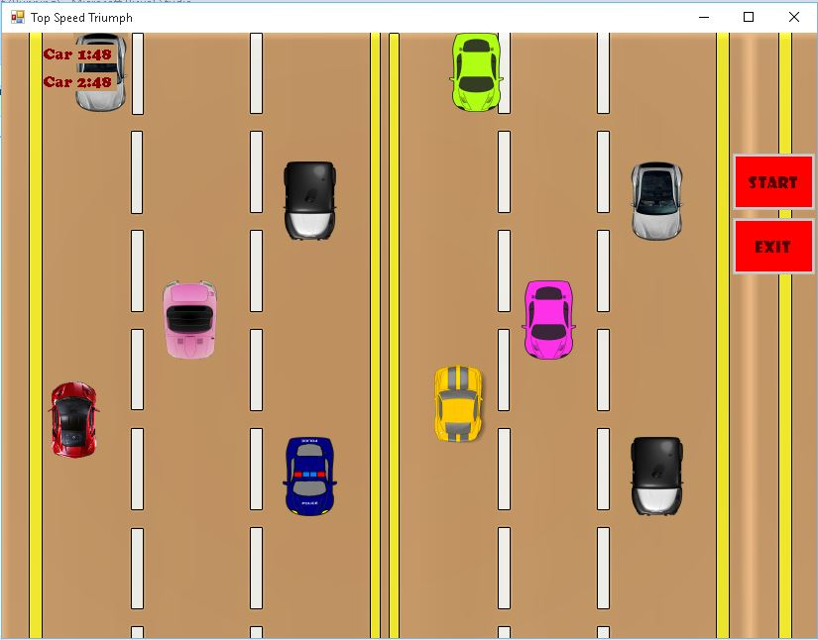 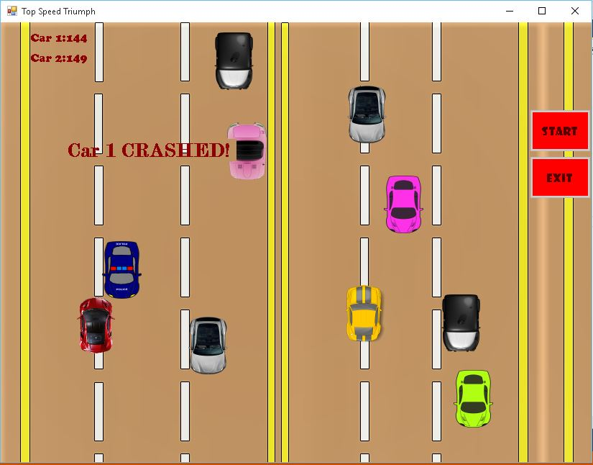

After Car 2 CRASHED: Game Over:

